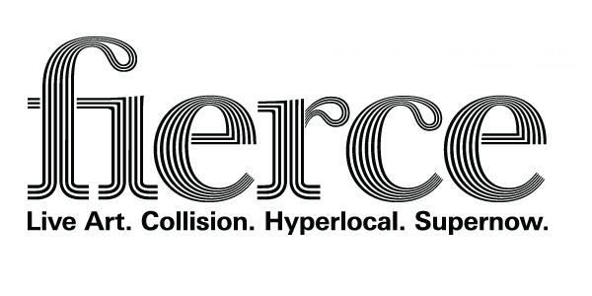
FIERCE 2013 - Volunteer Application Form
Name:
Address:
Post code:
Email:
Telephone:
Mobile:
Date of Birth:
Male/Female (please circle)
Are you…(please tick the relevant box)
Student ☐ Graduate ☐ Unemployed ☐
P/T Employed ☐ F/T Employed ☐ Retired ☐

Tell us about yourself and why you want to volunteer for Fierce? (max. 100 words)

[type here]

What artist or artistic experience has inspired or excited you in the last 12 months…(max. 100 words)
[type here]

AVAILABILITY
We ask our volunteers to do a minimum of four shifts with varying roles across the festival.
This year we will need volunteers between 24 September to begin the Get In at some events, until 16 October, as well as across the main festival weekend (4 - 6 October).
Shifts will be between 4 - 6 hours depending on the nature of the event.
There will be a sign up sheet at the volunteers briefing with more detail regarding shifts against the programme however if would be useful if you could note your availability below (available/not available ) so that we can begin to get an idea of capacity that would be great:
Date | AM | PM | EVENING
24 September
25 September
26 September
27 September
28 September
29 September
30 September
1 October
2 October
3 October
4 October
5 October
6 October
7 October
8 October
9 October
10 October
11 October
12 October
13 October
14 October
15 October
16 October

Please email completed applications forms to Sadie Newman at Sadie@wearefierce.org by 5pm, Thursday 5 September 2013.
Please note the volunteers briefing meeting will take place on Wednesday 11 September 2013, 6pm - 8.30pm at STRYX, Minerva Works, 158 Fazeley Street, Birmingham, Digbeth B5 5RS

